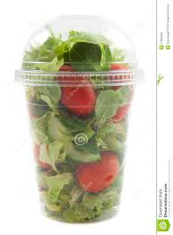
SALAD SHAKER $1.50
Diced Ham, Egg, Shredded Cheese, Lettuce, Tomato, Cucumber. Vegetarian option available as well.

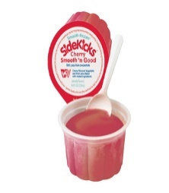
SIDEKICK 50¢
Smart Snack Approved. 4.4 fl. oz. of smooth-frozen, 100% fruit juice. Every cup has two flavors for irresistible appeal.

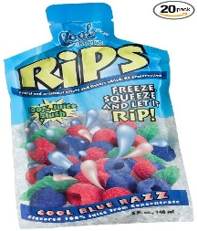
RIP SLUSH 50¢
Smart Snack Approved. 4 fl oz. of 100% Juice Slush, no sugar or artificial colors added.

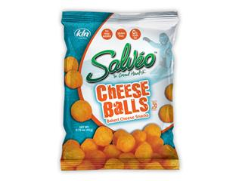
CHEESE BALLS 50¢
Smart Snack Approved. Oven Baked with all natural flavors or preservatives. This product is Gluten free and Cholesterol Free. Each package contains .75 oz.

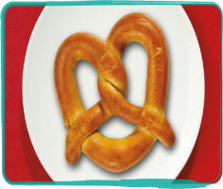
SOFT PRETZEL 40¢
Smart Snack Approved. Delicious, soft, warm pretzel is 51% whole grain soft and it delivers increased fiber and whole grain goodness.

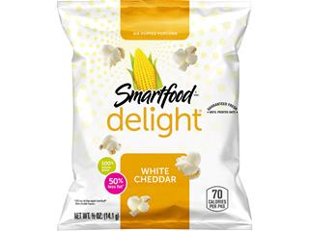
POPCORN, CHEDDAR 25¢
Smart Snack Approved. Whole grain white cheddar popcorn.

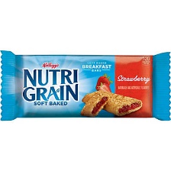
NUTRIGRAIN BAR 40¢
Smart Snack Approved. With real fruit, whole grains, and it is a good source of fiber.

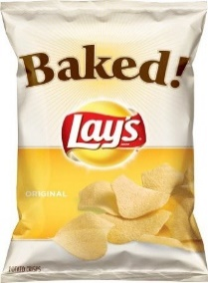
BAKED LAYS CHIPS 50¢ Smart Snack Approved. Oven Baked gives you the great taste you've come to love and 80% less fat than regular chips. Each package contains 0.875 oz.

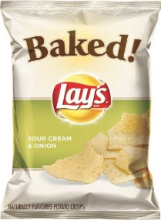
BAKED LAYS CHIPS 50¢ Smart Snack Approved. Oven Baked gives you the great taste you've come to love and 80% less fat than regular chips. Each package contains 0.875 oz.

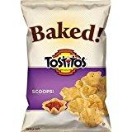
TOSTITO SCOOPS 50¢
Smart Snack Approved. Oven Baked whole grain goodness in every bite. Each package contains 0.875 oz.

